SEVEN LAKES LANDOWNERS ASSOCIATION BARCODE SPONSORSHIP FORM
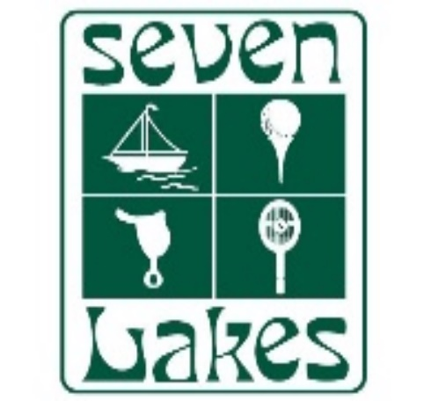
Date: __________________
Your Name: ______________________________________________
Your Address (mailing): ________________________________
________________________________
Your Address (physical): ________________________________
________________________________
Best Phone # to reach you: ________________________________
Your Email address: _______________________________
Please read and sign:
Per SLLA Rules and Regulations:
SECTION 2.0: ENTRY TO SEVEN LAKES NORTH AND SOUTH GENERAL RULES
2.1 Any individual entering the Community is subject to the Covenants, the Articles, the By-Laws, the Rules and Regulations, the published assessments and/or penalties and any other requirements as established by the Board for violations thereof. Anyone entering the Community must show proof of current membership or proper identification, as required by the Association, to Security personnel whenever and as often as required.
2.3 Guests and Visitors: Guests and other visitors will be allowed admission only if confirmed to the Association by member, affiliate member (over the age of 18), or authorized representative of the member. Email or telephone confirmation from the Owner may be requested by the Association or Security.
2.7.1 That each lot owner can only sponsor 2 barcodes per lot.
GUEST AND RENTER PROCEDURES.

5.3.1 Owners who rent, lease, or allow others to use their property or the various facilities and amenities to which the owner is entitled, shall be responsible for compliance with the Covenants, the By-Laws, and these Rules and Regulations by their guests, renters, and other visitors. The Owner shall be responsible for providing his/her guests or renters with a copy of these documents and for informing them that they are subject to and are obligated to observe the provisions of these documents
5.3.2 Renters and others occupying a house while the homeowner is not on the property must register with the SLLA office.
5.3.4 The Owner shall be responsible for any unpaid penalties levied against the user of his/her property, whether said user is his/her parent, child, guest, tenant, or other visitor. Owners who rent or lease their property will be charged an annual tenant administration fee for each long term tenant (30 days or longer).

Name of Sponsored Guest | Bar Code #
By signing here, you are aware that you may sponsor 2 vehicles to have a barcode (that do not reside in SLLA) per lot, and, that you will accept 100% responsibility for your guest/s. Myself and my guest/s understand that each bar code is $15 and is good for the period of one year.

Print Name: __________________________ Signature: ____________________________ Date: ___________

