**2021/22 Budget Discussion**

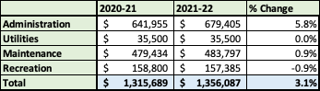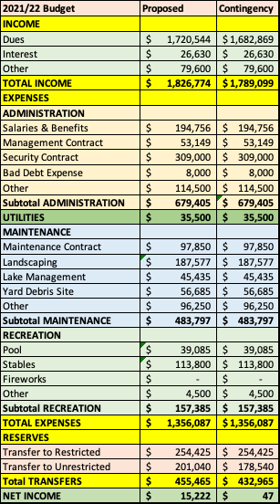

The proposed budget represents a $25 per lot dues increase.

The largest item increasing is the increase in Security costs, due to an expansion of hours we have available.

In addition, we have 2-3% increases in our major contracts, have assumed a 3% increase in salaries, and our yard debris costs have gone up.

Due to the continuing increase in cost, we have elected to do away with fireworks this year, and instead, will consider a “fireworks allowed” day for Independence Day.

We are expecting a $1.2 million state mandated dam drain for Sequoia this year.